**Objective:**

The objective of this assignment is to build, train, and evaluate a deep learning model for recognizing handwritten digits from the CIFAR dataset.

**Dataset Preparation:**

Steps:

1) Dataset Download:

   The Cifar-10 Dataset was downloaded using torch datasets using link -https://www.cs.toronto.edu/~kriz/cifar-10-python.tar.gz

2)

Following this the digit classes [0-9] were extracted

3)

Followed by creating Subsets for the digits.

4)

We then create a stratified Train/Val Split from the train_data (train_size = 0.8)

Len of Train Data before split = 50000 32x32 Images

Len of Train Data after split = 40k

Len of Val Data after split = 10k

**Model Selection:**

We build a model in pytorch framework namely ConvNet in the custom_model.py module

We also train the data on a pretrained resnet50 model employing transfer learning.

**Training :**

Two separate Models (Resnet50 Pretrained/my custom ConvNet) were trained.

The training_funcs.py module contains different functions to train/evaluate the model.

**Included different functionalities such as gradient accumulation, mixed precision, gradient clipping during training.**

**Created a stratified train/val split to detect signs of overfitting. Monitoring the tensorboard graphs along the traing process.**

**Used Data Augmentations like Horizontal Flip and Color Jitter to increase dataset diversity making the model more robust and more generalised/agnostic.**

**Used dropout regularisation in my custom model to deal with overfitting.**

Optimizer – AdamW

Scheduler – CosineLR

Loss – CrossEntropy



Training Snippet making use of Progress Bar

Model Save Strategy – Saving model having minimum absolute difference between train and val loss.

Training Graphs(Tensorboard) –

**For Resnet50**

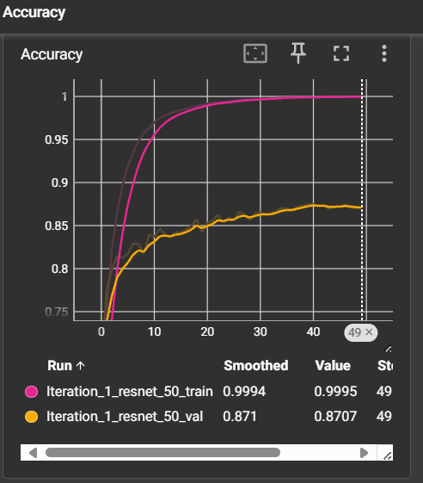 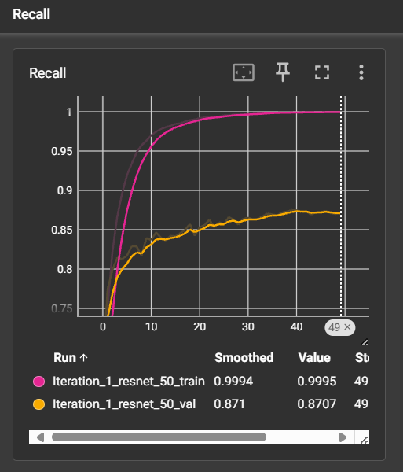

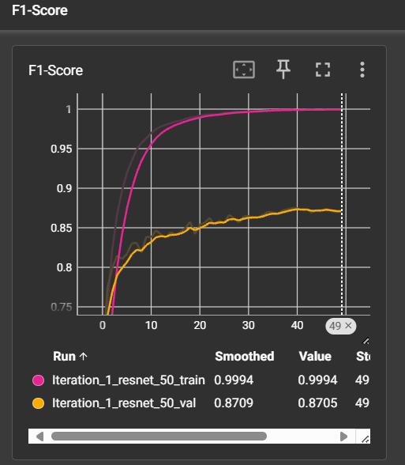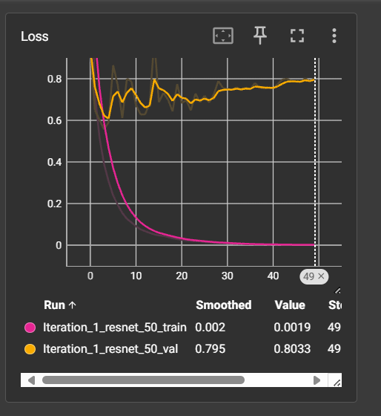

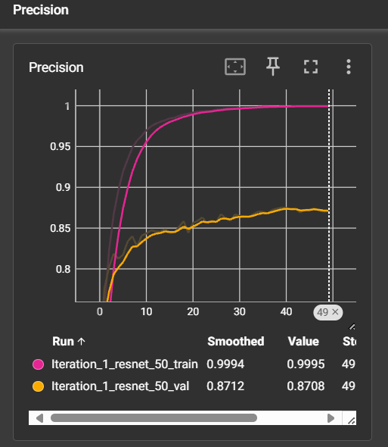

**For Custom ConvNet –**

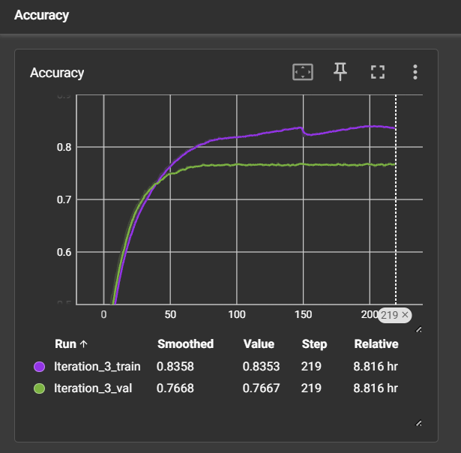 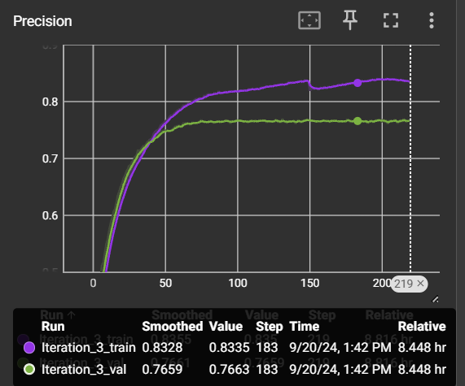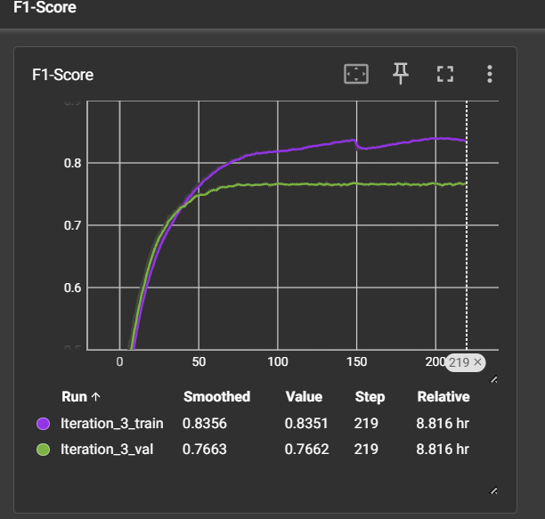 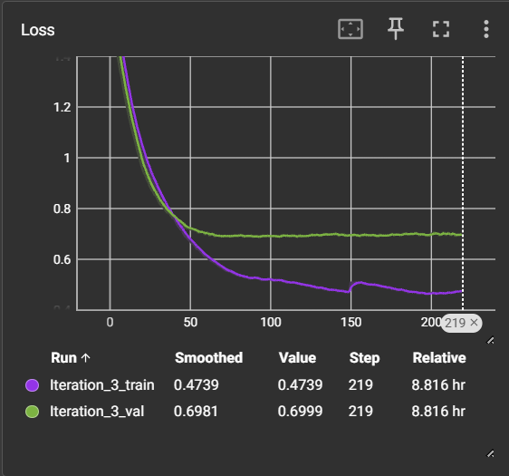 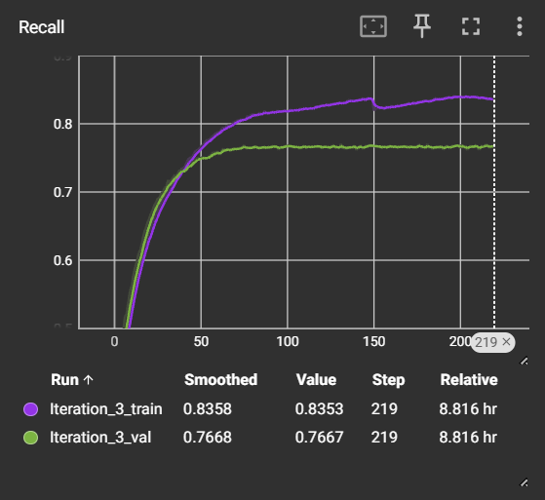

**Evaluation:**

The model was evaluated using the precision, recall, accuracy, f1  -score metrics from sklearn (with average=”macro”)

However I have also additionally provided a custom evaluation_metrics.py module to manually compute these metrics.

Performance on Test Set –

**For Resnet50 –**

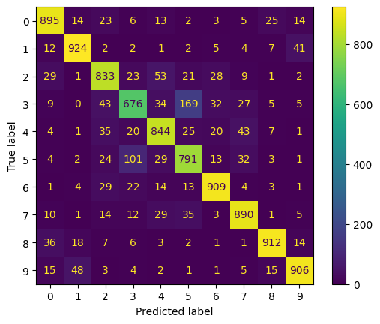

Confusion Matrix

testing accuracy: 0.85800

testing precision: 0.85776

testing recall: 0.85800

testing F1-Score: 0.85743

For the resnet50 model the best model was achieved in the 23rd Epoch. (Total 50 epochs)

**For my custom ConvNet -**

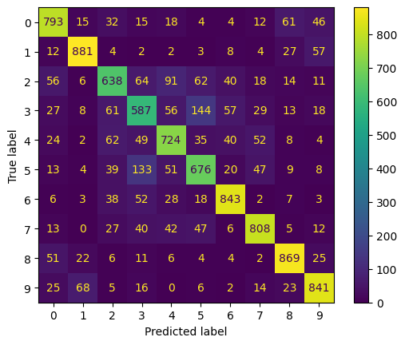

Confusion Matrix

testing accuracy: 0.76600

testing precision: 0.76442

testing recall: 0.76600

testing F1-Score: 0.76498

For the custom ConvNet model the best model was achieved in the 216th Epoch. (Total 220 Epochs)

**Conclusion and Recommendations:**

The two models (resnet50/my custom ConvNet) performed decently well on the cifar-10 test dataset. However the results could further be improved by using -

1) Incorporating more data augmentation techniques to handle edge cases

2) Experimenting with more advanced architectures.

3) Fine-tuning additional hyperparameters, such as the batch size, learning rate schedule, Epochs to optimize training performance.